MANAGER’S MESSAGE

We hope that the Christmas, New Year holidays have exceeded your expectations, with time spent relaxing with family and friends, a welcome break from another busy year running your farming businesses.
For many, thoughts will have turned to making plans for the year ahead. LMR members can offer solutions in part or whole to projects such as buildings and renewable energy schemes. Where your business is changing scale or enterprise mix the use of other members to provide contracting services might well be the most effective solution. LMR has an enviable range of skills and services to offer from within its’ membership. Please remember to include your fellow members in your plans.
LMR has been reviewing and renewing its offerings and operations. You may wish to visit LMR’s new website www.lmr.org.uk. You can download various forms, for example work sheets and also the machinery inventory service booklet that we encourage you to complete so we can keep the LMR members records up to date. We hope it provides information to keep you informed of the latest offerings

and information from us. It will also give prospective members a good overview of the diverse range of skills and services you as members and LMR have to offer. Please encourage your friends and neighbours to join LMR for all of the benefits we have to offer them.
Please come and see us at Lamma 2015 at Peterborough showground. It is always good to meet members and discuss future opportunities.

We would like to thank you all for your continued support and commitment to LMR. It should result in LMR having another successful year, which puts LMR in a strong position to be able to deliver savings and solutions for you in the year ahead. 2015 is bound to throw up unexpected challenges, but LMR and its’ members will do their utmost to be there with solutions.
As we have mentioned before this is “Your Ring” so let’s keep the work between the LMR members.
We are here to find the right member with the skills, experience and machinery for you.

With kindest regards
Jayne & Andrew

Rain Water Harvesting
LMR member
Agricultural specialist installers
Suppliers & system designers
Rainwater harvesting systems
Main water systems
Drainage/storm water management
___________

Spring Work
Contact LMR to book your requirements
Experienced LMR members available for Cultivations
and any other work that needs undertaking

_______

Next Event for LMR

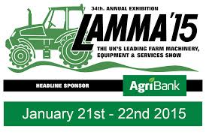
East of England Showground, Peterborough

Come and join us
On the LMR Stand in Hall 7

Spring Work
Contact LMR to book your requirements
Experienced LMR members available for Cultivations
and any other work that needs undertaking
___________

Generators – Harvest Hire

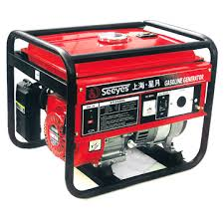

Pre Book your generator hire by the end to April
to qualify for even bigger savings

___________

Tanks
Various types of tanks available
At discounted prices for LMR members

Agricultural Spray Nozzles
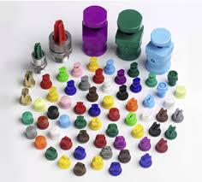
Discounts available to LMR members

ANTI-FREEZE OFFERS
Group deals available and the more you buy the better discounts you will receive

Qualube Universal Anti-freeze * Qualube Qualgard Hybrid Coolant *
Qualube Qualgard Hybrid 50/50 Coolant
Available in 1ltr, 5ltrs, 25ltrs and 200ltrs

Screen Wash & De-Icer also available at Wholesale prices

TO ALL MEMBERS

___________

Electricity/insurance/ finance

There are a number of brokers within LMR who will get you very competitive rates when you review your electricity, phones, insurances and finace deals. Please call for their contact details.

_______

Tanks
Various types of tanks available
At discounted prices for LMR members

___________

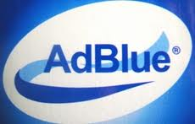

Highly competitive prices available

1000ltrs in the IBC
£264.55
including levy

210ltr barrels also available
at discounted prices

___________

Estate Maintenance
Fencing, Forestry, Hedge cutting, Ditching

Experienced LMR members available

___________

Feeling a bit chilly!
Great Offers on LPG Heaters
Cabinet, Site, Infrared

Forage
Please call LMR with your forage and straw requirements and product for sale. We will also have access to markets outside of the LMR area.

_______

There are a number of brokers within LMR who will get you very competitive rates when you review your electricity, phones, insurances and finance deals. Please call for their contact details.

_______

Forage
Please call LMR with your forage and straw requirements and product for sale. We will also have access to markets outside of the LMR area.

_______

WEARING PARTS & SPARES

LMR has big discounts on many spares and wearing parts from member firms such as

Spaldings, Knight Farm Machinery, AB Components and Altek to name a few.
Please remember to quote your membership when ordering.

Fencing
LMR has a wide choice of fencing contractors for all of your fencing needs. Posts and wire are also available from LMR members at competitive prices. Please call for further information.

_______

MEMBERS BOARD
For Sale
100 tonnes of fodder beat
Contact Jayne

For Sale
Wheat & Barley Straw, quads & 4x3’s
Hay, various sizes available
Contact Jayne or Andrew

Wanted
Sprayer Operator
Permanent Vacancy
Market Rasen & Lincoln areas
Contact Jayne

Wanted
Self-Propelled trailed
and mounted crop sprayers
Contact Jayne

DAILY PRICES AVAILABLE
FUEL – GAS OIL – DERV – HEATING OIL

